Nightly Reading Record Sheet
December

Student’s signature____________________________________ Parent’s signature______________________________
Color 1 gingerbread boy after at least 5-10 minutes of reading each night. Return the completed sheet by the end of the month.
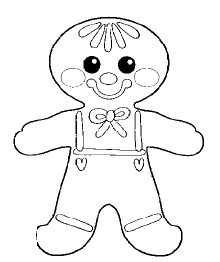



Nightly Reading Record Sheet
January

Student’s signature____________________________________ Parent’s signature______________________________
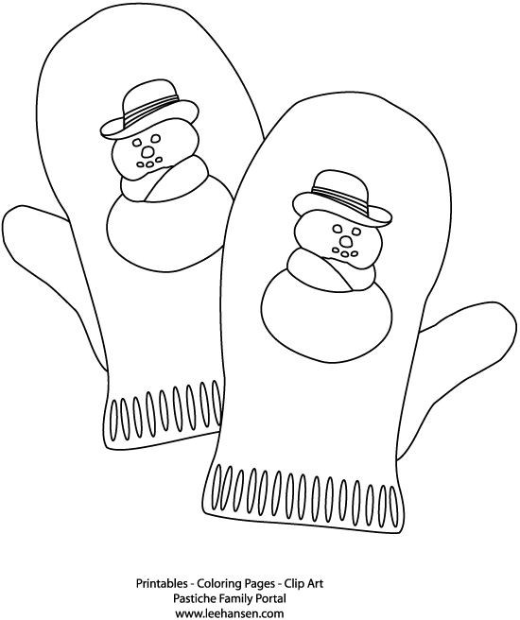
Color one pair of mittens after at least 5-10 minutes of reading each night. Return the completed sheet by the end of the month.
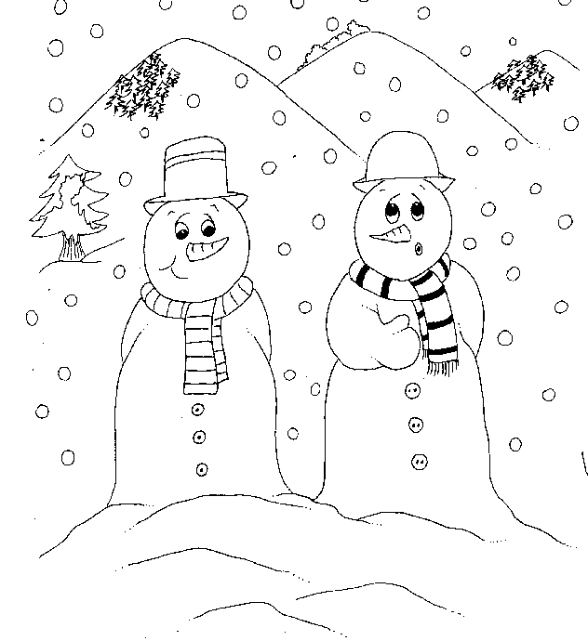

Nightly Reading Record Sheet
February

Student’s signature____________________________________ Parent’s signature______________________________
Color one heart after at least 5-10 minutes of reading each night. Return the completed sheet by the end of the month.

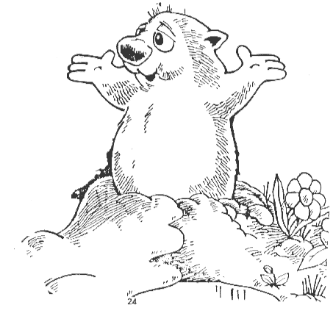

Nightly Reading Record Sheet
March

Student’s signature____________________________________ Parent’s signature______________________________
Color one shamrock after at least 5-10 minutes of reading each night. Return the completed sheet by the end of the month.

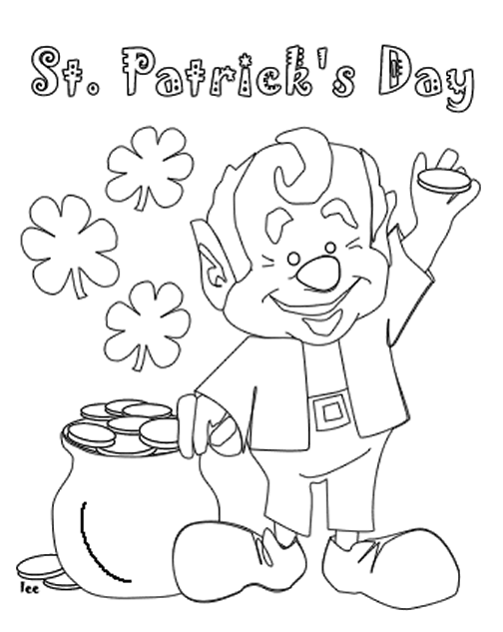
.

Nightly Reading Record Sheet
April

Student’s signature____________________________________ Parent’s signature______________________________
Color one raindrop after at least 5-10 minutes of reading each night. Return the completed sheet by the end of the month.
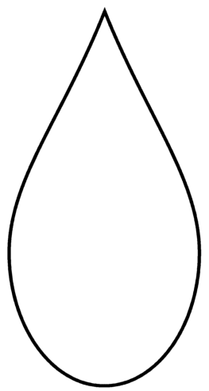


.

Nightly Reading Record Sheet
May

Student’s signature____________________________________ Parent’s signature______________________________

Color one flower after at least 5-10 minutes of reading each night. Return the completed sheet by the end of the month.
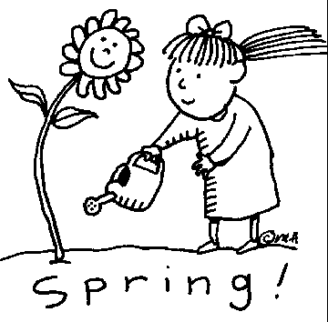

Nightly Reading Record Sheet
June

Student’s signature____________________________________ Parent’s signature______________________________

Color one sun after at least 5-10 minutes of reading each night. Return the completed sheet by the end of the month.


Nightly Reading Record Sheet
September

Student’s signature____________________________________ Parent’s signature______________________________

Color one apple after at least 5-10 minutes of reading each night. Return the completed sheet by the end of the month.




Nightly Reading Record Sheet
October

Student’s signature____________________________________ Parent’s signature______________________________
Color one pumpkin after at least 5-10 minutes of reading each night. Return the completed sheet by the end of the month.

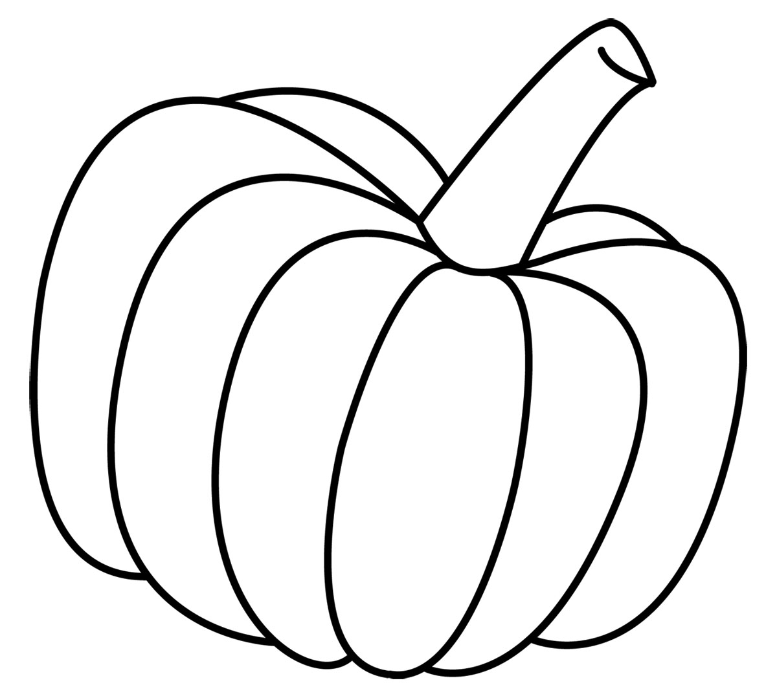

Nightly Reading Record Sheet
November

Student’s signature____________________________________ Parent’s signature______________________________
Color one turkey after at least 5-10 minutes of reading each night. Return the completed sheet at the end of the month.

